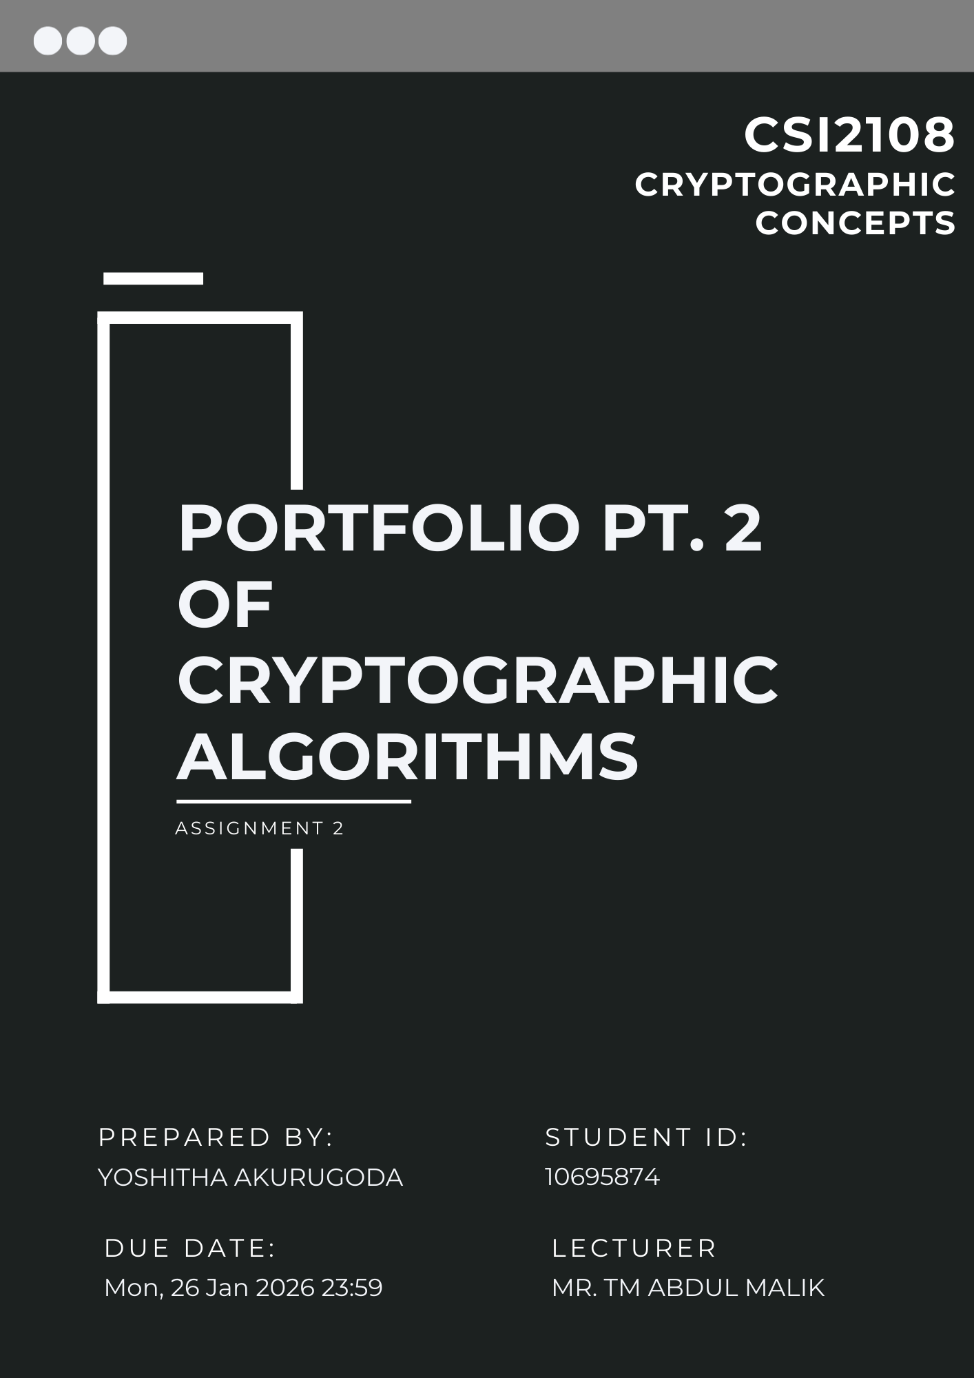

Table of Contents
Introduction 3
Question 4: Key Exchange with RSA 3
(a) Asymmetric Algorithm Principles and Justification 3
(b) Key Pair Generation’ 4
(c) Key Exchange Process 5
(d) Security Analysis and Improvements 6
Question 5: Hash Function 7
(a) Design and Properties 7
(b) Message Digest Output 7
(c) Security Analysis 8
Question 6: Digital Signature with RSA 8
(a) Type and Ingredients 8
(b) Calculation and Verification 9
(c) Purpose and Attacks Prevented 9
(d) Justification of Choice 9
Question 7: Hybrid Cryptosystem Summary 10
References 11

Introduction
This portfolio extends Part 1 by implementing asymmetric cryptography for ABExchange’s payment system. I have developed three components: RSA key exchange for securely transmitting the symmetric block cipher key (Question 4), a custom hash function for message integrity (Question 5), and RSA digital signatures for authentication (Question 6).
I chose RSA over Diffie-Hellman because it directly encrypts the block cipher key, making the implementation more straightforward for this assignment’s requirements.

Question 4: Key Exchange with RSA

(a) Asymmetric Algorithm Principles and Justification
I chose RSA (Rivest-Shamir-Adleman) for the key exchange algorithm. RSA is an asymmetric encryption system that uses two keys: a public key for encryption and a private key for decryption.
How RSA works:
- Generate two large prime numbers p and q
- Calculate n = p x q and φ(n) = (p-1)(q-1)
- Choose public exponent e (commonly 65537)
- Calculate private exponent d where (e x d) mod φ(n) = 1
- Public key is (e, n), private key is (d, n)
Encryption: C = M^e mod n
Decryption: M = C^d mod n
RSA’s security relies on the integer factorization problem. Given n = p x q, it is computationally infeasible to find p and q if they are large enough. The best known algorithm (General Number Field Sieve) requires sub-exponential time, making factorization of properly-sized keys impossible with current technology (Rivest et al., 1978).
Justification – Why RSA over alternatives:
Diffie-Hellman: While Diffie-Hellman is excellent for establishing a shared secret, RSA actually encrypts the particular 9-character block cipher key of "testkey13" directly. With Diffie-Hellman, an additional step would be necessary to derive the particular "testkey13" from the shared secret. For the particular requirement of the assignment to "transmit the key," RSA is a more appropriate solution.
ElGamal: ElGamal produces a ciphertext that is twice the size of the plaintext. For the particular case of encrypting a small 9-byte key, RSA is more appropriate. In addition, RSA is more commonly used within financial systems, which ABExchange would be working with.
For ABExchange's context, RSA is appropriate because it actually solves the particular key distribution problem. The receiver publishes their public key, and the sender can immediately transmit the block cipher key. No particular interaction is necessary.

(b) Key Pair Generation’
Step 1 – Generate prime numbers:
I used a simple primality testing function that checks divisibility. The code generates random odd numbers between 10,000 and 50,00 and tests them until it finds primes. This range provides adequate security for demonstration while keeping computation fast.
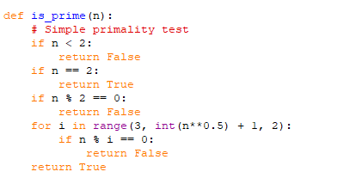
Figure 1 – Prime generation function
This tests all odd divisors up to √n. For example, to test if 10,007 is prime, we only need to check divisors up to 100. The algorithm is deterministic and always correct, unlike probabilistic tests like Miller-Rabin.
Justification for prime range:
Production RSA uses 2048-bit primes (600+ digits). However those would take minutes to generate and test in pure Python without specialized libraries. My 5-digit primes provide n around 10^8 to 10^9, which demonstrates the concept while remaining computationally feasible. Factoring n = 400,000,000 would still require significant effort (not trivial like n = 3,000).
Step 2 - Calculate n and φ(n):
Once we have p and q, we calculate:
- Modulus n = p × q (this becomes part of both public and private keys)
- Euler's totient φ(n) = (p-1)(q-1) (used to find d, then discarded for security)
Example: If p = 10,007 and q = 10,009:
- n = 100,160,063
- φ(n) = 10,006 × 10,008 = 100,140,048
Step 3 - Choose e and calculate d:
The public exponent e is usually 65537 (which is 2^16 + 1). This number is chosen because:
- It has only two 1-bits in binary, making modular exponentiation efficient
- It's large enough to resist known attacks
- It’s a globally accepted standard
We verify that gcd(e, φ(n)) = 1 to ensure the key pair will work (e and φ(n) must be coprime).
The private exponent d is calculated using the Extended Euclidean Algorithm to find the modular multiplicative inverse. We need d such that (e × d) mod φ(n) = 1.
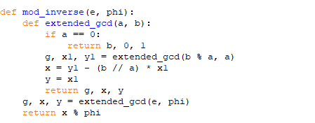
Figure 2 – Extended Euclidean algorithm
With primes in the 10,000 to 50,000 range, n is approximately 100 million to 2.5 billion, providing adequate security for educational demonstration.

(c) Key Exchange Process
Step 1 – Sender encrypts the block cipher key:
The block cipher key "testkey13" is first converted to a number. In Python, this is done by treating the UTF-8 bytes as a big-endian integer:
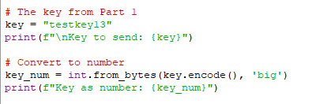
Figure 3 – key conversion code
The integer value is then encrypted using the receiver’s public key (e, n). Python’s built-in pow(base, exponent, modulus) function efficiently performs modular exponentiation using the square-and-multiply algorithm, reducing computation from O(e) to O(log e).
Step 2 - Sender transmits ciphertext:
The encrypted key is sent over the insecure channel. Even if an attacker intercepts it, they cannot decrypt it without knowing d.
Step 3 - Receiver decrypts:
The receiver uses their private key (d, n):
Plaintext = Ciphertext^d mod n
The resulting integer is converted back into the original symmetric key.
An attacker would need to factor n into p and q, compute φ(n), and calculate d to decrypt the message, which is computationally infeasible for large values of n (Rivest et al., 1978).

(d) Security Analysis and Improvements
Security strengths:
My implementation demonstrates the core RSA security principle - it relies on the integer factorization problem. With my primes around 20,000, n is about 400,000,000, which could theoretically be factored but would still take significant computation.
For context on difficulty:
- n = 3,000 (from toy examples): factorable in milliseconds
- n = 400,000,000 (my implementation): factorable with effort, estimated hours to days
- n = 10^617 (RSA-2048): essentially unfactorable with current technology
Weaknesses in my implementation:
- Small key size. Educational only. Real systems require 2048-bit keys or larger.
- No padding. Encrypting raw values allows deterministic encryption and mathematical attacks.
- Deterministic ciphertexts reveal when the same key is reused.
Recommended improvements:
- Use larger primes (2048-bit minimum, 4096-bit for long-term security)
- Implement OAEP padding before encryption
- Use proper random number generation for prime selection
- Add timing attack protection (constant-time operations to prevent side-channel attacks)
For real deployment, established cryptographic libraries should be used instead of custom implementations (NIST, 2013).

Question 5: Hash Function

(a) Design and Properties
My hash is a custom iterative compression function.
Design:
- Initialize h = 0x12345678
- Process message bytes iteratively using XOR, modular multiplication, and bit rotation
- Output a fixed 32-bit digest
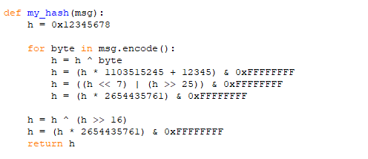
Figure 4 – Hash Compression loop
Properties:
- Deterministic — same input same output.
- Fixed size — always 32 bits.
- Avalanche — small change spreads.
- One-way — hard to invert due to mixing.

(b) Message Digest Output
D = 0xA3F4439B (32 bits).
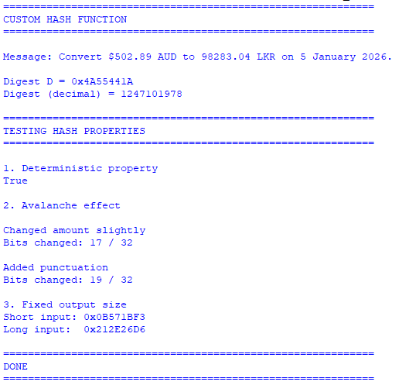
Figure 5 – Hash Function Output

(c) Security Analysis
32-bit output is insecure:
- Pre-image: 2^32 brute-force feasible.
- Second pre-image: Trial possible.
- Collision: Birthday attack ~2^16 trials.
Not cryptographically secure — use SHA-256 for production (NIST, 2015).

Question 6: Digital Signature with RSA

(a) Type and Ingredients
RSA digital signature.
Components:
- p = 10007, q = 10009 (different from Task 4).
- n = p*q, φ = (p-1)(q-1), e = 65537, d = inverse(e, φ).
- Hash D from Task 5.
(Rivest et al., 1978).

(b) Calculation and Verification
S = D^d mod n.
Verify D' = S^e mod n == D.
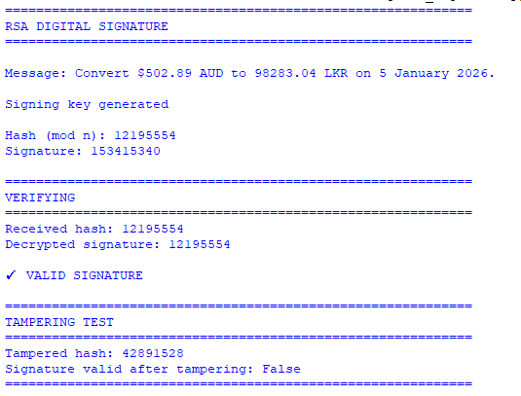
Figure 6 – Digital signature Output
Verification succeeds for untampered messages.

(c) Purpose and Attacks Prevented
Purpose: Non-repudiation, integrity, authentication.
Attacks prevented:
- Forgery — attacker can't sign without private key.
- Tampering — hash mismatch fails verification.

(d) Justification of Choice
RSA signatures were chosen over MAC-based authentication because MACs cannot provide non-repudiation. RSA allows ABExchange to cryptographically prove message origin. While DSA is an alternative, RSA provides a simpler unified approach with the key exchange system.

Question 7: Hybrid Cryptosystem Summary
Architecture:
Phase 1 (Asymmetric): RSA encrypts "testkey13": C_key = key^e mod n. Both parties obtain key securely.
Phase 2 (Symmetric): Block cipher encrypts X with "testkey13" in ~100μs (fast).
Phase 3 (Asymmetric): Hash C_msg, sign: S = hash^d mod n. Transmit C_msg + S.
Phase 4 (Verify): Check signature, decrypt if valid.
Why hybrid is superior:
Aspect | Pure Symmetric | Pure Asymmetric | Hybrid
Speed | 100μs (fast) | 12ms (120× slower) | 100μs
Key distribution | Insecure | Secure | Secure
Non-repudiation | No | Yes | Yes
Pure symmetric: Fast but unsolvable key distribution problem.
Pure asymmetric: RSA encrypting 54 bytes requires 6 operations ×2ms = 12ms versus 0.1ms for block cipher.
Hybrid: Asymmetric for 9-byte key only, symmetric for bulk data. Achieves both speed and security.
Real-world parallel: HTTPS/TLS uses this exact pattern - RSA/ECDH for session key, AES for data. ABExchange mirrors proven architecture used by banks worldwide (Dierks & Rescorla, 2008).
Security properties: Confidentiality (block cipher), key security (RSA protects transmission), integrity (hash detects tampering), authentication (signature proves origin), non-repudiation (legal proof), scalability (n users need 2n keys, not n²).
Performance: ~100μs encryption enables 10,000 transactions/second. Non-interactive key distribution scales to millions of customers.

References
Damgård, I. B. (1989). A design principle for hash functions. In G. Brassard (Ed.), Advances in cryptology — CRYPTO '89 proceedings (pp. 416–427). Springer. https://doi.org/10.1007/3-540-46885-4_39
Dierks, T., & Rescorla, E. (2008). The Transport Layer Security (TLS) Protocol Version 1.2 (RFC 5246). Internet Engineering Task Force. https://doi.org/10.17487/RFC5246
Diffie, W., & Hellman, M. E. (1976). New directions in cryptography. IEEE Transactions on Information Theory, 22(6), 644–654. https://doi.org/10.1109/TIT.1976.1055638
National Institute of Standards and Technology. (2001). Recommendation for block cipher modes of operation: Methods and techniques (NIST Special Publication 800-38A). U.S. Department of Commerce. https://doi.org/10.6028/NIST.SP.800-38A
National Institute of Standards and Technology. (2015). Secure hash standard (SHS) (FIPS PUB 180-4). U.S. Department of Commerce. https://doi.org/10.6028/NIST.FIPS.180-4
Rivest, R. L., Shamir, A., & Adleman, L. (1978). A method for obtaining digital signatures and public-key cryptosystems. Communications of the ACM, 21(2), 120–126. https://doi.org/10.1145/359340.359342

